User Interface Design
- for Web Sites

A presentation for the
Consultancy in Residence Program
Gregory Terrace School

Jan Williams
Gordon Joughin
Griffith Flexible Learning Services
Griffith University 2000



Introduction
Although the CIR project will be delivered on a CD-ROM, web technology will be used to create the screens and most of the interface. In fact the product will consist of a web site on a CD-ROM. For this reason, this session will focus on designing for the web, with a few exceptions where the delivery mechanism (the CD) impacts on design considerations.

Aims
- To gain an overview of interface design principles.
- To highlight critical aspects of interface design.
- To highlight common mistakes in interface design.
- To provide a starting point for further investigation.
- To practice key ideas in a short exercise.

Before you start
Two important questions before you start designing a site:

- What is the purpose of your site?
- Who is your audience?

What is the purpose of your site?

The first issue that should inform the design of any software product is its purpose. What is the product supposed to do? Web sites fall into various broad categories, and different categories have different purposes. For example, business sites are usually designed to help sell a product or a service, and sites for clubs and groups provide useful information for members.

What other kinds of sites are there?

The main purpose of a product influences how it will be designed, and how information is presented and accessed.

What is the purpose of the CIR project site?

Who is your audience?

The 'type' of users that can be expected to use your product will influence your design choices. Even if you don't know exactly, some idea of a target group or percentage of the available audience you wish to reach can be useful.

For example, geographical location, age group, and expected type/level of technology may affect choices of software versions, graphical content, and programming.

Who is the audience for the CIR project site? Is there more than one?

So what?

Design principles
Web sites, no matter what their purpose, tend to have some common features or attributes. In this exercise, we'll have a look at a web site and identify its main features.

Features of a web site

(1) Consistency

The most important thing that you can possibly do is make sure that your user interface works consistently. If you can double-click on items in one list and have something happen then you should be able to double-click on items in any other list and have the same sort of thing happen. Put your buttons in consistent places on all of your windows, use the same wording in labels and messages, and use a consistent color scheme throughout. Consistency in your user interface allows your users to build an accurate mental model of the way that it works, and accurate mental models lead to lower training and support costs (Ambler, 1998, p1).

Consistency is the key to making your user interface design function in a smooth and 'seamless' manner. A good user interface design should make access to the required content easy and logical. It should not be an end in itself or get in the user's way.

Browser interface
One consideration with web site interface design is the fact that any design that we create is always framed by another pre-existing interface design - that of the web browser in which the page loads. This can be both a hindrance and a help.

For example, we know that there will be certain inherent features in a web browser, such as the 'back' button, but we also know that we must also deal with the inherent 'bugs' and idiosyncrasies of the browser.

Navigation
Placing standard buttons such as 'next', 'previous' and 'home' in the same location on each screen of your site will allow users to quickly learn how to efficiently use your site. This will also speed up access to materials for your user enabling them to navigate your site more quickly, and find the materials they require. This reduces user frustration.

Formatting
Consistency is a primary consideration in the creation of the 'content' for your web site.

(2) Understanding

Metaphors
You may wish to use a metaphor when designing your interface. Metaphors can assist the user in bridging the gap between the 'real world' and the computer interface. The most famous computer metaphor is perhaps the Macintosh 'desktop' metaphor, however there have been many others, sometimes related directly to the discipline in which the software is used, and others more general.

For example, an online shop may use a 'store front' metaphor with an entrance, showroom, accounts, service desk etc

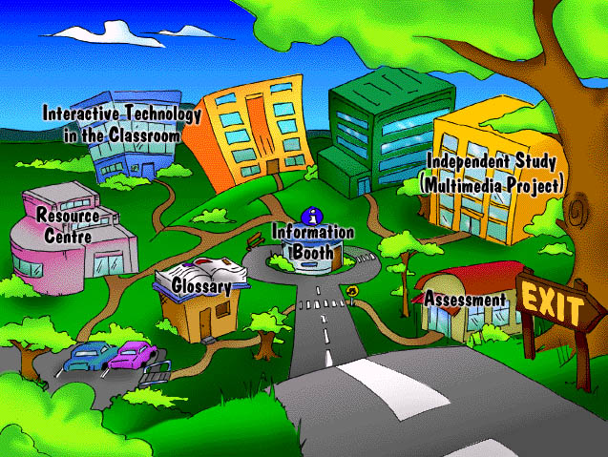
Figure 1: "MITAC" uses a "campus" metaphor for a university course on a CD

Writing style
Writing for the web (or any computer based product) requires a different style of writing than is required for print. Most users won't sit at a screen and read through enormous blocks of text. Text should be presented in small bites or chunks.

A good overview for each section allows the user to make informed choices about whether they wish to proceed.

Accessibility
Will your site be accessible to people with disabilities? There are many ways to enable users with disabilities to easily access web sites, and alternatives can be provided for content which will not translate. For example:

- Use appropriate 'alt' tags for all images, to provide an 'alternative text description' of the image.

- Provide text navigational alternatives. Along with alt tags the provision of a text based navigational aids can provide access for users with disabilities. If the majority of the information on your web site is text based, it may simply be a matter of providing a text based site map.

- Provide alternative text descriptions of movies, sounds, and multimedia components.

Screen design

Menus and buttons. The fundamental purpose of screen design is to provide access to information and interactions that the user requires for that part of the program. Logical placement of menus and buttons is a must. Place frequently used buttons in a convenient and logical place (users should not have to 'click all over the place' to perform routine functions).

Crowding. Do not crowd your screen with too much information. It is better to have two sequential screens than to attempt to put all the required information onto one extremely full screen layout.

Windows. Label all windows and 'pop ups' sensibly, with meaningful titles. Search engines usually look in the 'title tags' for information regarding the content of the page, so pages called 'Home Page', 'My Page' and 'Untitled' are not terribly useful!

Navigation

Site maps. A large site benefits from a well organised site map. Site maps provides the user with a quick overview of the major sections of the site, and enables them to access their required section easily.

Number of clicks. The fewer clicks users have to make to get to their destination the better. More then three selections in a row to get there and they can lose interest. So the 'depth' of information on your site and how it is organised is important. Well designed menus and navigation bars can reduce the number of 'clicks' needed.

(3) Visuals

Fonts
Heading size. Make sure that your font size and heading choice reflects the structure of your information.

★ For example, if you have three sections, you may begin each section with 20pt bold, and subsections with 16pt bold. Be careful to check that you have not accidentally started a 'subsection' with a 'section' heading. In large documents it can be easy to lose track of where you are in terms of headings and structure.

Variety. Keep the variety of fonts used in your pages to a minimum. You may wish to use a sans serif font for your headings and a serif font for your body text, but the inclusion of many more font types begins to confuse the structure of the document rather than enhance it.

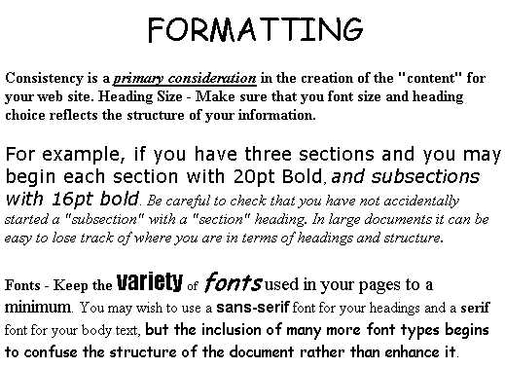
Figure 2: The effect of using a variety of fonts.

'Art' fonts. 'Art' fonts are extraordinarily difficult to read on screen. Use 'art' fonts, such as copperplate or fancy scripts as headings only. It is wise to make these headings as graphics too, unless you can be absolutely certain that the user has the very same font on their machine. In most cases your swish font will display as Times or Arial on the user's machine.

Colours

Selection. Be careful with your colour choice. Some users may be colour blind, or have some other visual impairment. Some colour combinations are difficult to read the screen for all users - for example yellow text on a white background.

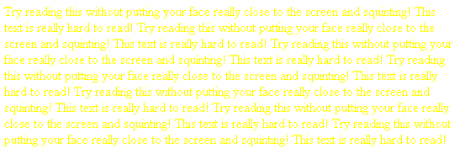
Figure 3: The Effect of a poor colour combination

Backgrounds. Avoid busy, intricate background images for your web pages, unless you plan to have very minimal text to be read over the top of it.

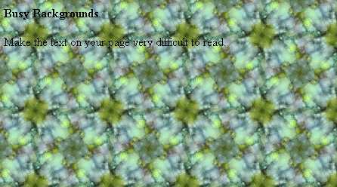
Figure 4: The effect of busy background patterns

Graphics
Usually, the more images you have on your web page, the longer it will take to download. The CIR project is a little different in that it will be delivered on a CD, minimising the 'download time' issue. However, judicious usage of graphics is a principle well worth following, whatever the project. Two key questions to ask are:

- Are the graphics simply there for decoration? Or do they add to the meaning of the content? Not that decoration is inadvisable per se, but avoid over use of graphics without good reason.

- Do the graphics convey their meaning without further explanation? In particular, icons should convey an immediate and obvious message.


Figure 5: What do these icons convey on their own? The user is required to roll their mouse over them before they make sense! (Source: http://www.webpagesthatsuck.com/badnavigation.html)

Animation
Does the animation add to the meaning of the content, or enhance the user's understanding in some way? Numerous spinning bars and buttons, simply for decoration, take up unnecessary bandwidth, and usually annoy and frustrate the user after more that one visit.

(4) Functionality

Forms and interactions
Error messages and other communications with the user should be logical and jargon free. When your user is required to click a button to submit a form or interact with some software, make sure that the button is labelled intuitively, so that the user knows what task they are about to perform.

Align fields in an easy to read, logical way.
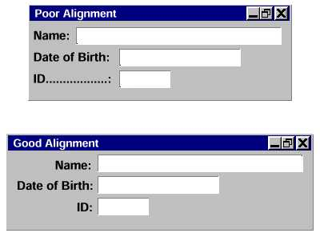
Figure 6: Small changes in field alignment can make a big difference (Source: http://www.ambysoft.com/userInterfaceDesign.pdf)

Meta-data

Meta-data is descriptive information about your HTML page, which resides at the top of the page, and is usually 'invisible' to the user.

One of the primary functions of Meta-data in web pages is to assist search engines in organising access to information, although there are many other uses for Meta-data (such as timed release of information, expiry dates etc). It also allows you to keep track of who created the page, and when it was last edited.

Below you will find some standard types of Meta-data you may wish to include in your pages:

<meta name='Title' content='Title of your page'>
<meta name='Description' content='Information describing your page'>
<meta name='Keywords' content='Key, Words, Here'>
<meta name='Version' content='1.00'>
<meta name='Author' content='Name'>
<meta name='VersionDate' content='1999-12-21'>

Conclusion

Well designed pages are consistent, easy and logical to navigate. They are legible and quick to download. Well designed pages need not be boring. It is possible to design exiting, interesting sites, with graphics and interactions, that follow good design principles.

It's a matter of balance. Sites are there to fulfil their purpose, (the reason why the site was created in the first place). A site may have nice graphics, pop up windows and icons, but as soon as design elements begin to detract from the function or accessibility of the site then it is time to reconsider your design choices.

Keep your sites functional, consistent and logically organised and you will be on the track to good web design.

Further reading

Alexander, E and Tate, M (1999) Web Wisdom : How to Evaluate and Create Information Quality on the Web, Lawrence Erlbaum Associates, New Jersey.

Lynch, J and Horton, S (1999) Web Style Guide: Basic Design Principles for Creating Web Sites, Yale University Press, New Haven.
http://info.med.yale.edu/caim/manual/

Spool, J et al (1999) Web Site Useability: A Designer's Guide, Morgan Kaufmann Publishers, San Francisco.

Useable Web - A collection of sites relating to good web design
http://www.usableweb.com/

IBM Web Guidelines
http://www.ibm.com/ibm/hci/guidelines/web/print.html

IBM Ease of Use Web Guidelines
http://www-3.ibm.com/ibm/easy/eou_ext.nsf/Publish/572

User Interface Design Tips - For software in general (not just the web - but most principles still apply)
http://www.ambysoft.com/userInterfaceDesign.html

The Web Software Design Audit - Checklist of design elements with tips
http://www.eng.buffalo.edu/~ramam_m/au_fr.html

Web Content Accessibility Guidelines 1.0 - Guidelines for making web sites accessible to people with disabilities.
http://www.w3.org/TR/WAI-WEBCONTENT/

Web Pages That Suck - Learn by not doing!
http://www.webpagesthatsuck.com/home.html

How to make an annoying web page - Elements that make up an annoying web page.
http://www.users.nac.net/falken/annoying/main.html

Dr Tom's Meta-Data Primer - Explanation of Meta-Data
http://www.imsproject.org/drtommeta.html

Activity
You have the following information provided from a "content capture" sheet. How would you arrange it on the screen?

Name: | Mr Joe Bloggs
Years at Terrace | 8
Associated Events/Years: | 1956
Related media: | Photo of Mr Bloggs 
Stories | Text Text Text Text Text Text Text Text Text Text Text Text Text Text Text Text Text Text Text Text Text Text Text Text Text Text Text Text Text Text Text Text Text Text Text Text Text Text Text Text Text Text Text Text Text  Text Text Text Text Text Text Text Text Text Text Text Text Text Text Text Text Text Text Text Text Text Text Text Text Text Text Text Text Text Text Text Text Text Text Text Text Text Text Text Text Text Text Text Text Text Text Text Text Text Text Text Text Text Text Text Text
Author(s) | A Student

What other sorts of things will you need on the screen?

Try working out a screen layout on the blank screen (overleaf).
